|  |  |
| --- | --- |
| UX Design Techdegree  Redesigning a T-shirt Website  Case Study by John Orduno |  |

Table of Contents

Mockups

Redesign Summary

Design Principles

Moodboard

Mockups

Device Mockup

Project Summary

Optimizing for Mobile

Mobile Mockups

Mobile Device Mockup

The Problem to Solve

Target Users

Target audience

Stakeholder Interview

Hypothesis

Problems

Competitors

Goals

Strategy

# 

# Mockups

# Redesign Summary

Articulate how you approached the redesign and the decisions you made. 6-8 complete sentences

|  |
| --- |
| I redesigned just about everything. I tried to shrink down the elements that don’t display the product as much as possible. I wanted most of the focus to be on the photographs. I know the tutorials say not to use code fonts, but this is a site for coding students, so I designed the typography with that in mind. I added more positive language and tried to inject a bit of humor into the site as well for a more pleasurable experience. I used colors and designs that are a little more reminiscent of Treehouse. A Treehouse student would definitely associate the color scheme with a site that has something for them. |

## 

### Design Principles:

Color

Did you change the color palette? Or the way color is used? Explain your decisions below.

|  |
| --- |
| I changed the color scheme completely. I simplified it down to three colors. The green, white, and gray loosely follow a Treehouse scheme. I wanted a dark grey to kind of simulate a terminal or IDE screen where a student would see his code typed out. The green and white make perfect colors for the text to look like code on the dark gray background. I used solid white because Treehouse does too. The color scheme didn’t look right with off-white. |

Color Palette

|  |  |  |  |
| --- | --- | --- | --- |
|  |  |  |  |
| Almost Treehouse Green  #2CD59C | Super Dark Gray  #444343 | White  #FFFFFF |  |

Typography

Provide details about your typography choices. You can have one or more. If the font has different weights, include those. Specify if a certain font is used for headings, and another is used for body text.

Fonts

|  |  |
| --- | --- |
| Consolas | Looks a lot like code, but still easy to read at larger sizes. |
| Segoe UI | Decent x-height... readable when small. Simple and easy to read. |

## 

### Brand Personality

When creating text, or copy, for a web-app, it’s important to think about the voice you want to use. A brand personality is one way to determine how you want the brand to sound to its users. This keeps the voice and message consistent across the entire web-app. Place an ‘X’ in the table below to mark the traits ShirtsByMike’s brand personality will have. (One ‘X’ per row) Feel free to change the text or add new rows.

|  |  |  |  |  |  |  |
| --- | --- | --- | --- | --- | --- | --- |
| Personality Table | | | | | | |
| Casual |  | x |  |  |  | Formal |
| Stylish | x |  |  |  |  | Conservative |
| Spontaneous |  |  | x |  |  | Planner |
| Fun |  | x |  |  |  | Serious |
| Warm & Friendly | x |  |  |  |  | Detached |
| Quirky | x |  |  |  |  | Conventional |
| Inclusive |  |  |  | x |  | Exclusive |

### Brand Personality Explanation

Explain the brand personality you decided on in at least 6-8 sentences. Why will the users respond to this type of voice? How will it help ShirtsByMike reach their goals?

|  |
| --- |
| I picked a personality that was quirky, friendly, humorous, and positive. A Treehouse shirt isn’t a necessity like auto insurance. It’s something the user will get because it is cool and fun to wear and represents something they are passionate about. I made it a bit exclusive for Treehouse coders. I feel like non-coders would find the text decorations a little confusing, but that coders might think it is cool and original. I used some photos of people who look like they could be Treehouse students wearing some coder shirts and the Mike shirt so that users can see what they might look like wearing one. I used language that coders would understand, and added some depth to Mike the Frog’s character. The user is asked to bring Mike home so that he can join them on their journey through tutorial purgatory to defeat their imposter syndrome. Again, non-coders might not understand. |

### Moodboard

Create a collage of at least 10 images that represent the brand. You can create a board on [Pinterest.com](https://www.pinterest.com) then combine the images in your favorite design program. Be sure to credit the creators by including their names on your moodboard.

|  |
| --- |
| <https://drive.google.com/file/d/1Wu8-nL_tPW0IA102L16led_yLEHI0zMT/view?usp=sharing> |

# Adding Text Content

|  |
| --- |
| **Text Content Types:**   * Descriptive Content * Helpful Content * Transparent Content * Inspirational Content |

## 

## Text Content Explanations

What type(s) of text content will you use on this project? Why? 6-8 complete sentences.

|  |
| --- |
| Since custom t-shirts aren’t a necessity, I focused on the content mostly being inspirational. The product descriptions are geared towards inspiring the user to feel good / feel connected with the product. I kept the descriptive content down to the necessities: shirt color and size. For content that is helpful, I tried to create button text and links that are easy to follow. The next step shouldn’t be difficult for our average user to figure out. The most transparent content are the ‘about’ statement on the home page, and the body text on the contact us page. Short and sweet, the ‘about’ statement says that the shirt will be a quality product, a cool product, and a comfortable product. On the contact page, I tried to convey a sense of the company being committed to the customer… eager to listen and quick to respond. As a user, I want to know that if I have a problem or want to suggest the next cool shirt, the company is listening. |

## Mockups

*Include a link to your image(s) in Google Drive along with placing them below.*

|  |
| --- |
| <https://drive.google.com/file/d/1lLBsEMGW2q6r7Py2eLfbyL3ODJvVmlz-/view?usp=sharing>  <https://drive.google.com/file/d/1vd2sXLpb4nSN0YlmmbzNBusyrosfJv6i/view?usp=sharing>  <https://drive.google.com/file/d/13jiC3Tc1inHBtvJOrGNoMh0rCLs3pkZn/view?usp=sharing>  <https://drive.google.com/file/d/1HtUJAqwX-12--WhiayhwDIZZn4WOJL5_/view?usp=sharing> |

## Device Mockup

Give your case study polish by adding a mockup of the design on a device. Do this for the original website design too, so you can show a before and after comparison. You can use [shotsnapp.com](https://shotsnapp.com/) which has free templates of various devices; all you need to do is upload an image of your design.

*Include a link to your image(s) in Google Drive along with placing them below.*

|  |
| --- |
| Insert device mockups here  <https://drive.google.com/file/d/1M_NyglQDDxoh9t7_4qKd1pvBQx3HDDbG/view?usp=sharing>  <https://drive.google.com/file/d/17dxwa2g90Yxi0uVqD5RxT-BceRD5SaHP/view?usp=sharing>  <https://drive.google.com/file/d/1udD78_HGOQ19sD_JVYdDNQ13tYUIGiCX/view?usp=sharing>  <https://drive.google.com/file/d/1v6oMyOINs_u3EF8KCOHk9vtgiWkBjXdB/view?usp=sharing>  <https://drive.google.com/file/d/1gaZSdGLJTf3VrahoN4l82TJ6msYBxNY1/view?usp=sharing>  <https://drive.google.com/file/d/1WrY0mzOio8mhOAMTlcmECg0CFQsiEAtU/view?usp=sharing>  <https://drive.google.com/file/d/1khtJjvJib82yo-YblfMTVETSy-ouNjxe/view?usp=sharing> |

## Project Summary

What did you learn from this project? 3-4 complete sentences

|  |
| --- |
| I definitely learned how much work really goes into designing a good website. All of the little details of the text, the mood of each image, the balance of the colors and the content… There is a lot to think about. I am surprised at myself for being able to improve this site at all and how much cooler I made it from the things I have learned! |

What would you do differently next time? 3-4 complete sentences

|  |
| --- |
| I feel like I could delve in even deeper to the tiny details and improvements needed for this site. I would definitely iterate my wireframes more and see if I couldn’t simplify the site I came up with even more. I would aim for a little less clutter on the mobile version. I would possibly even start with the mobile design instead. I had difficulty finding room for everything. I also wouldn’t try and fit everything onto one screen as much...I seem to forget that phones can scroll. |

EXCEEDS

## Optimizing for Mobile

Describe the design decisions you made to make the website mobile-friendly. Note you're tasked with making the website easy to use on a mobile phone; you're not expected to make a mobile app. 5-6 complete sentences

|  |
| --- |
| Honestly, I mostly just tried to make it look less boring. I did, however, feel that a hamburger menu was in order. The menu could add some more functionality to the mobile site while keeping it less cluttered. Since on the web mockups, I focused on large photos, it was difficult to do the same on mobile. I had to start putting things on top of the photos / making the photos smaller, or removing them completely. The only place I didn’t have to compromise on that was the catalog. I like that the catalog on mobile looks better while focusing on one single picture, taking up most of the screen. It was also easier and looked better to make things more blocky for mobile. All the corner radii of the web mockups didn’t look or feel right on mobile. |

## Mobile Mockups

*Include a link to your image(s) in Google Drive along with placing them below.*

|  |
| --- |
| <https://drive.google.com/file/d/1VMOAQ6okma63MvlS2U6R15GLadPybL9a/view?usp=sharing>  <https://drive.google.com/file/d/1LA_VWOdPjQqV0nNCcfP6-e7d_nyEipTI/view?usp=sharing>  <https://drive.google.com/file/d/1G98rFNn8UhAqf_DpjQahMdIpKOe02tx5/view?usp=sharing>  <https://drive.google.com/file/d/1OL97KjvKrWXps7zQhzp2Brd-qK3R3KfY/view?usp=sharing>  <https://drive.google.com/file/d/1XPlKrYIvKqJAOpv8ACpgdIn0BTDDjWCV/view?usp=sharing> |

## Mobile Device Mockup

*Include a link to your image(s) in Google Drive along with placing them below.*

|  |
| --- |
| <https://drive.google.com/file/d/1HyoTGpqAhIduOv0ksA13GJ8VJolx7Mt0/view?usp=sharing>  <https://drive.google.com/file/d/1OQHw79VlVDBqPO9sflmni2vVBJlVdh-z/view?usp=sharing>  <https://drive.google.com/file/d/1ICjKYCugieD6wKHHdpHNHWnDRhK-wO-q/view?usp=sharing>  <https://drive.google.com/file/d/1amOHjfoHywRy02pIQKUfDqAEfm1v2KAJ/view?usp=sharing>  <https://drive.google.com/file/d/1usxYQT6XMKsgq_iNGVmZYHgmDis_u8fc/view?usp=sharing>  <https://drive.google.com/file/d/18vPBiYetY8cmbm_nhexoDnpejJRePHSi/view?usp=sharing>  <https://drive.google.com/file/d/1mJSs-wiS5lZhZuJPSaHLaWitnRdhBiJN/view?usp=sharing>  <https://drive.google.com/file/d/1-mHkebznzmm-lZM1ELSB-PqQDw3i_S8b/view?usp=sharing> |

# The Problem to Solve

You have been tasked with critiquing [shirtsbymike.com](http://shirtsbymike.com), an e-commerce website that sells t-shirts. Your client wants to know if anything should be changed to make the site look and/or function better for their customers. You will need to describe the design elements you see on the site and determine what improvements need to be made. Explain each improvement so your client understands how it will benefit their customers.

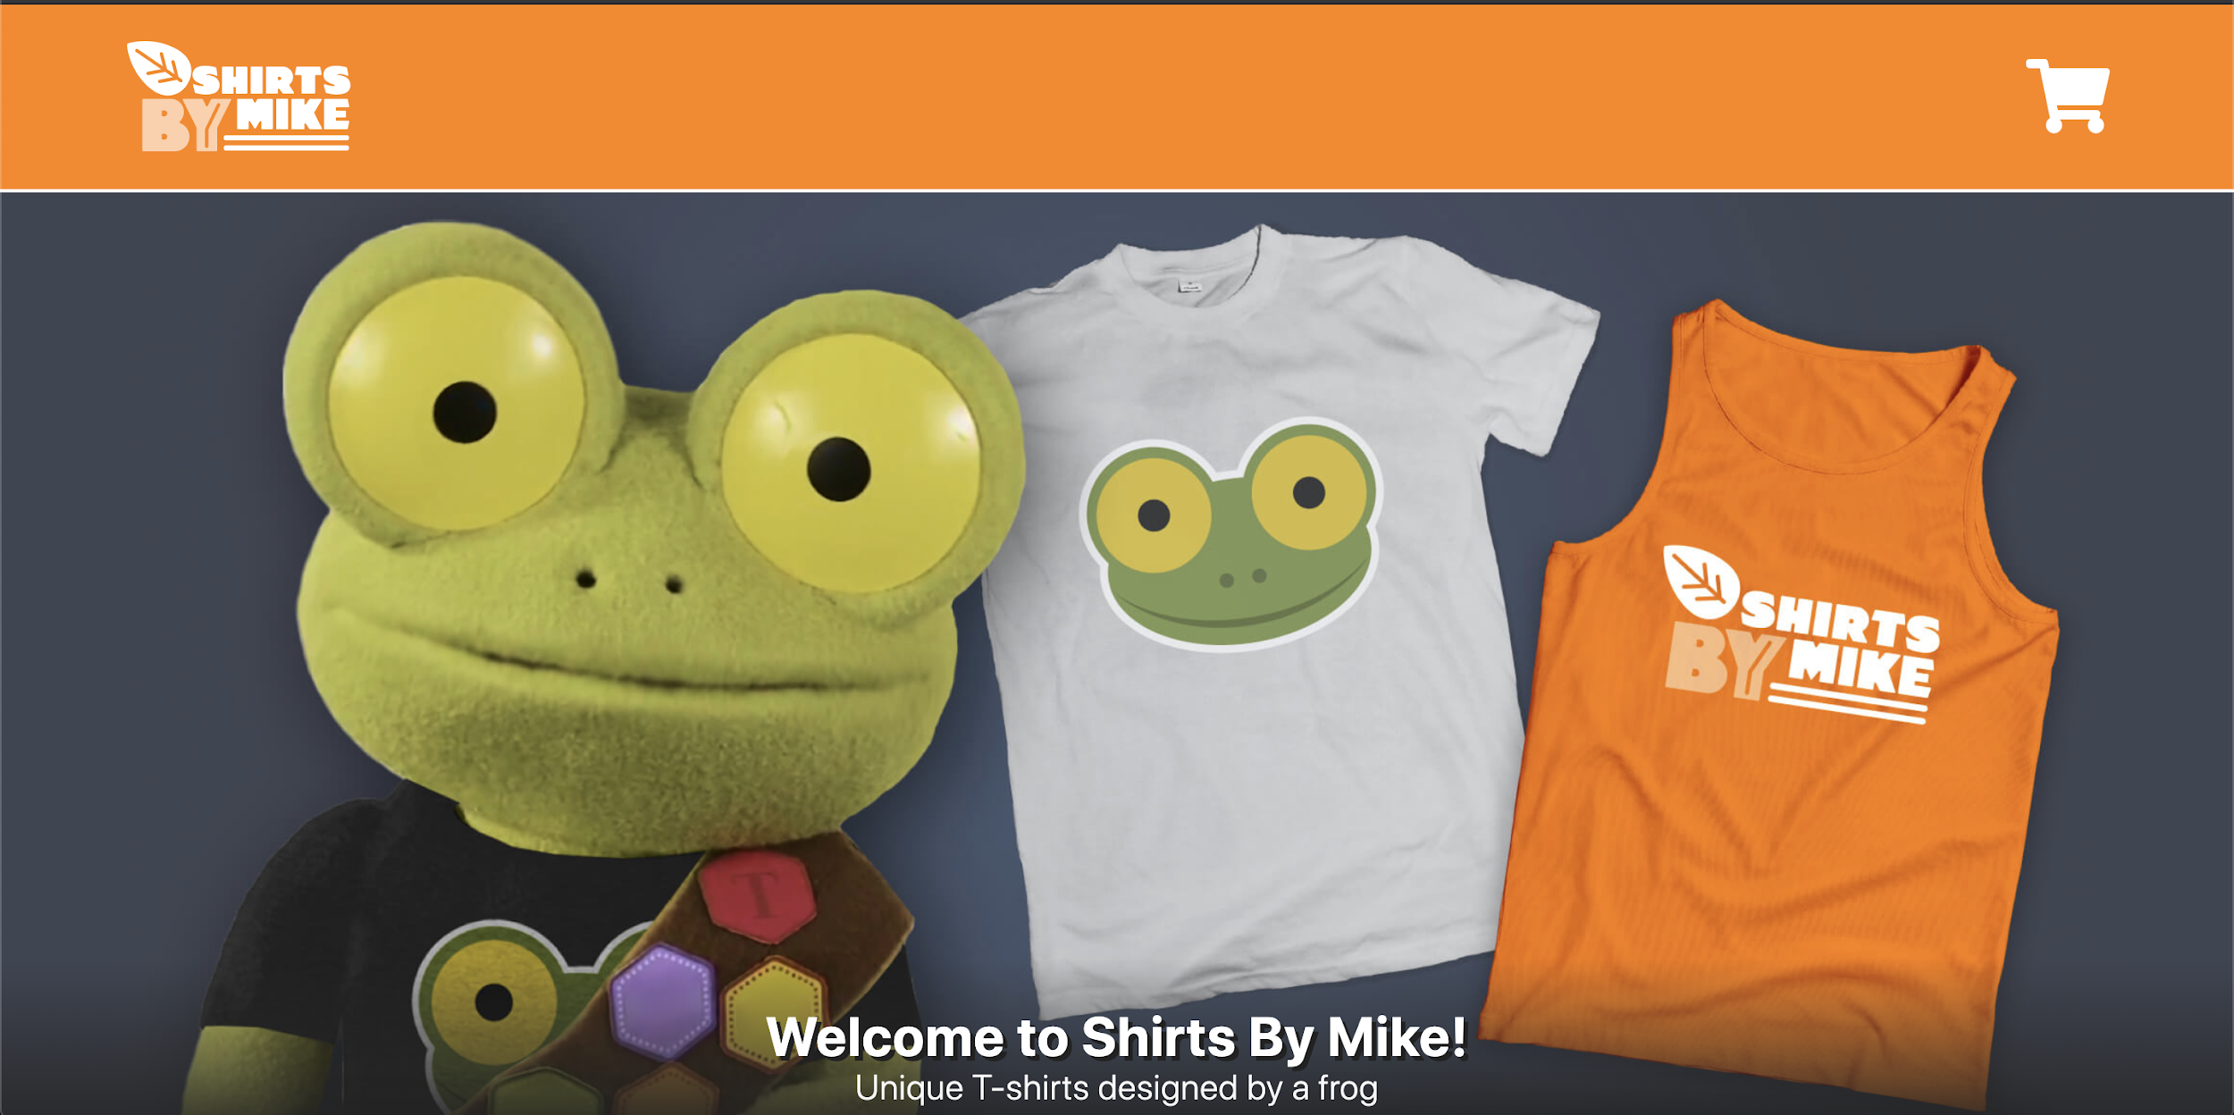

## Target Users

Shirts By Mike has provided you with this information about their audience. This research represents the primary users of this website.

|  |  |
| --- | --- |
| Target audience Mostly ages 16-35  Primarily based in the United States  Treehouse students  Lifelong learners  Values community  Playful |  |

## Stakeholder Interview

The project lead was interviewed, and here are the meeting notes. This provides information about the business.

|  |
| --- |
| Roberto Jiang, Marketing Director of Shirts By Mik |
| Hypothesis Treehouse students want t-shirts that are fun and make them feel connected to the community. Problems  * Our website is dated. Feel free to refresh the branding, if needed. * The content looks stale; we want to keep it fresh with various campaigns. * We are unable to highlight a featured t-shirt.  Competitors [designbyhumans.com](https://www.designbyhumans.com/) - t-shirts  [threadless.com](https://www.threadless.com/) - t-shirts  [teepublic.com](https://www.teepublic.com) - t-shirts Goals *What should this project accomplish for the business?*  We'd like to launch a featured t-shirt of the month. The goal is to increase t-shirt sales by providing a limited edition t-shirt.  *How will you, personally, define success for this project?*  These are the success metrics:   * Increase sales by 20% * Increase unique page visits by 10%  Strategy *In what direction is the business heading?*  We're aiming to continue providing quality t-shirts to the Treehouse audience. |

# 